Circle Language Spec: Interfaces

Interface Referencing and Redirectioning
This article contains examples of what diferent interface referencing and redirectioning situations would look like in a diagram and what name we could give to this situation.

Interface Reference
An object’s specification of which interface it has, is also called an interface reference.



Command Class Interface


Class Command Interface
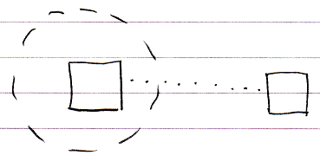

Command Definition Interface Redirection
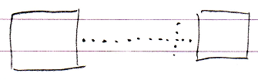

Command Reference Interface Redirection
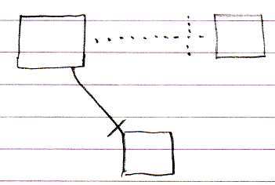

Command Call Interface Redirection
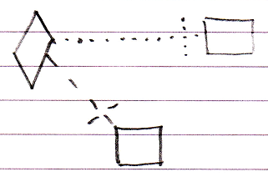

Active Clause Interface Redirection
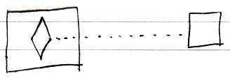

Inactive Clause Interface Redirection
